Group 4

- Spanish flu is often misnamed: where does its name come from?
____________________________________________________________________________________________________________________________________________________________________________________________________________________________________________________________________________________________________________
________________________________________________________________________________________________________________________
Here are some terms you can use: to originate – neutral - censorship – to dampen – to carry
Answer: Despite the misnomer, the Spanish flu did not originate in Spain. During WWI Spain was neutral, so their press didn’t have any wartime censorship and they reported freely on the virus as it began to wreak in the country. Other countries were experiencing the effects of the virus, but their press was not allowed to report on anything that might dampen morale. Spain’s lack of censorship made it appear the t the virus originated in Spain. Actually, it began in Kansas (US) and was carried in Europe by American soldiers.
- Which were the causes of Spanish flu?
____________________________________________________________________________________________________________________________________________________________________________________________________________________________________________________________________________________________________________
________________________________________________________________________________________________________________________
Here are some terms you can use: unsanitary – malnourished – packed – to carry – unhealthy – to spread
Answer: The virus was transmitted in the air, and the unsanitary living conditions at the time aided the transmission of the disease. Militaries were moving quickly across the globe, they were malnourished, packed in the trenches and got easily ill; unknowingly, they carried the disease with them. Back home, living conditions were not much cleaner or healthier and illness spread quickly.
- Look at the graph and match the characteristics of each Spanish flu pandemic wave with the right number of wave and the measures adopted by governments.

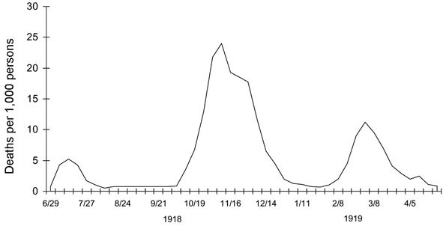

Wave characteristics measures
First wave | Milder version – low mortality rate | No special measures adopted by governments
Second wave | mild wave – typical flu symptoms (chills, aches and fever) | Use of mandatory quarantines, face masks and lockdowns
Third wave | strong effects on young adults – weakened bronchial tubes - could strike quickly, killing people within hours of the first symptom. Fever and fatigue, in extreme cases blue skin and risk to suffocate – no medicines or antibiotics – poison by aspirin overdoses | mortality rate normal for any other flu of the season
Fourth wave | milder version but high mortality between young adults - caused a shortage of food and so a famine and unemployment | Use of mandatory quarantines, face masks and lockdowns

Solution:

First wave | mild wave – typical flu symptoms (chills, aches and fever) | mortality rate normal for any other flu of the season
Second wave | strong effects on young adults – weakened bronchial tubes - could strike quickly, killing people within hours of the first symptom. Fever and fatigue, in extreme cases blue skin and risk to suffocate – no medicines or antibiotics – poison by aspirin overdoses | Use of mandatory quarantines, face masks and lockdowns
Third wave | milder version but high mortality between young adults - caused a shortage of food and so a famine and unemployment | use of quarantines and lockdowns
Fourth wave | Milder version – low mortality rate | No special measures adopted by governments

- Fill the gaps in this text about peace treaties of WWI.

Winner countries of WWI were 1) __________in peace treaties by the big 4s: Lloyd George (UK), Orlando (Italy), Clemenceau (France) and Wilson (US). They thought that Germany would have been able to 2) _______all debts thanks to its industries. But, as in other states after WWI, wasn’t so easy to 3) ________ war industry in normal industry. And the US were calling for their 4) ________ with France and England. President Wilson 5) _________ the 14 points, a political document with some ideas to follow during peace treaties to 6) _________ peace; the most important point concerns the birth of The league of Nations, an intergovernmental alliance to 7) ________ a new war.
J. M. Keynes in “The economic consequences of the Peace”, published in December 1919, 8) __________ the treaty of Versailles; he was against the 9) ____________ of heavy reparations on Germany. In his opinion, treaties didn’t contain any 10) ___________ for economic rehabilitation of Europe or to restore 11) ____________ with Russia. He proposed international loans for European countries and a 12) __________ of German reparations payment.

Words: produced – avoid – reduction - transform – provision - repay – credits - represented – relations – avoid – relations - maintain – criticized

Solution: 1 represented 2 repay 3 transform 4 credits 5 produced 6 maintain 7 avoid 8 criticized 9 imposition 10 provision 11 relations 12 reduction

5.Europe 1914 and 1919: what’s changed? Which are the new countries?
